LANDIS-II Visualization Tool v1.0

Last Revised by M. Lucash: November 7, 2026

This tool is designed to enable forest managers, researchers and other users to quickly and easily view maps and charts from LANDIS-II without using ArcMap or Excel.
For best results using the Visualization Tool, use the current Mozilla Firefox Browser or Google Chrome. The Visualization tool will NOT work with Internet Explorer.

Displaying the Data
Use the website provided by the modeler to utilize the visualization tool. Click on the website to pull up the main menu. Initially there will not be any maps or charts displayed on your screen; only the main drop down menu will be shown on your computer.
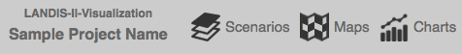
To display a map or chart, click on the word “Scenarios” and then use the corresponding drop down menu to select which scenario you want to visualize. You can select one scenario (e.g. climate change scenario) or compare more than one scenario by selecting multiple scenarios in the scenario drop down menu (click in boxes to the left of the names).
Each scenario (e.g. climate change scenario) contains a number of datasets that can be visualized as maps or charts. Datasets are organized by LANDIS-II extensions in the drop down menus. To display maps, click on the word “Maps” to see what data is available. Use the check boxes to select the ones you want, and then click on the main screen (white space) to display the maps. To display charts, click on the word “Charts” and select the parameters of interest. Again, click on the main screen to load the charts. You might have to resize your browser window to get them to display in a 2 X 2 arrangement.
The maximum number of displayable maps (or charts) is four.
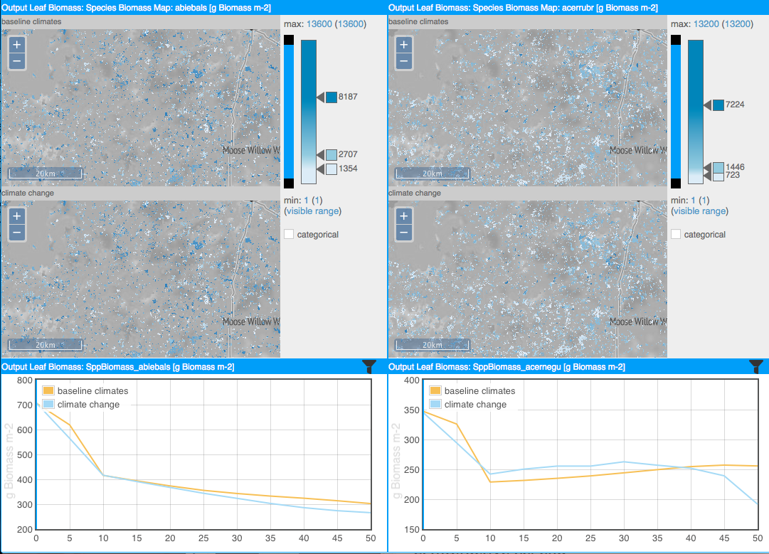

Altering how the Data is Displayed

Use the plus and minus buttons to zoom in and out of the map. Available zoom levels are set by the software administrator at the time of creating the map tiles; zoom level limitations are a result of these settings. Click and drag to pan on the map. If you navigate in one map window, all other map windows will update to the new location and zoom level automatically.
The default settings for the classification bar are calculated based on dataset statistics over the entire time period availability of the dataset; this is necessary to allow temporal animation. If more than one scenario is activated, statistics are calculated based on the entire time period and range of the parameter in all scenarios.
However, you can adjust the legend/classification bar (see right) to set class breaks, add or remove classes, change colors, and switch between continuous (interpolated colors) and discrete color schemes (color bins). You can also adjust the maximum and/or minimum displayed on the screen. If also possible to add classes by double clicking on the classification bar to add another class; double click a class break arrow to remove the class. Click a color square next to a class break arrow to assign a different data color to the class. Select the categorical option to switch to color bins. Drag the arrow next to a class break to move the break. To filter map data to show only a certain data range, drag the black squares on the filter bar to adjust the visible range.
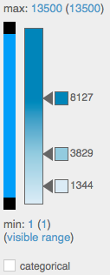
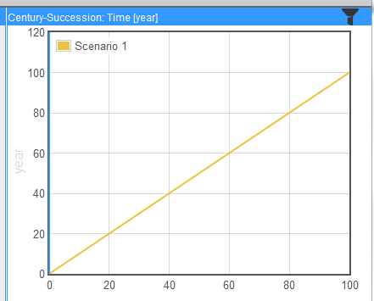
To filter chart data, click the filter icon on the right of the chart’s title bar. Select a filter criterion (e.g. ecoregion) and filter value to see a temporal chart for spatial areas that correspond to the filter value.

Viewing Changes over Time
Click the play button on the top menu bar to start a temporal animation.
On charts, the moving blue vertical line helps identifying parameter values that correspond to the current point in time. The maps are updated by displaying the map corresponding to the current time step. Interactive legend and spatial navigation are enabled while the animation is running. Click on the gears symbol to the right of the temporal animation bar to adapt animation speed.
By default the playback interval is by year. If a parameter on a map has a time interval of 5 years, the map is updated every 5th year. Maps, where time steps are available only every 10 years, is updated every 10th year.

For more detailed information about the tool, please read the LANDIS-II Visualization Tool v1.0 User’s guide.

